Board of Directors
League of Women Voters of Greater Birmingham
205 583-5000
admin@lwvgb.org

Virginia Randolph, President

Nancy Ekberg, 1st Vice President

Kate Long, 2nd Vice President

Cissy Bennett, Secretary

Sarah McDonald, Treasurer

Kaydee Erdreich-Breman,
Transit

Paulette Rowe,
Health

Beverly Nelson,
Observer Corps Jefferson County

Leonette Slay,
Environment

Carol Ann Vaughn,
Member

Kathryn Kerchof, Editor
The Voter

Betty Warnock,
Nominating Chair

Yvonne Brakefield,
Nominating Committee

Jean Johnson,
Off-Board Technical Director

Ann Smith,
Off-Board Observer Corps Water
Works

June, 2007


LWVGB has a new address!

LWVGB
P.O. Box 530522
Mountain Brook, AL 35253

It’s Your League -- A Note from the President

My mother was a League president in Mesa, Arizona. I was thinking the other day that she was born before women received the right to vote. That history made involvement in the League more important to me. It also made me realize what a relatively short time it has been. It is like trying to remember a time before computers. Things have changed, but it is still important to be educated about issues and to be engaged in our community development.
We want to hear from you! We on the LWVGB Board continue to send you information, but we know that you have things to share with us. With that in mind, please contact us at anytime at our e-mail address admin@lwvgb.org.

- Tell us how you would like to participate. If you can give 30 minutes or an hour, we will connect you with activities that help.
- Do you want monthly meetings, or are you someone who would rather receive electronic information?
- Would you be willing to receive action alerts on legislation to contact your elected officials?
- After receiving e-mailed action alerts would you be willing to contact our interested members without computers via telephone?

The New Board We want to welcome Kathryn Kerchof and Leonette Slay as members of the board and Paulette Rowe who is moving from off-board to an on-board position.

Planning by the Board Your new board is moving into this next year with planning activities after meeting with our outgoing President, Yvonne Brakefield. During the past two years Yvonne guided us another step-up in development, and we plan to keep her close to us for her wise and always pleasant counsel.

- Your new board will be planning our year in more detail on July 28th. We have already set up the dates for board meetings and membership meetings. Everyone is welcome to both board and membership meetings, and we will share those dates with you after we fill in some details on July 28th. Some are already listed in the calendar.
- Some items that we will be considering at our planning session include
* Advocacy issues
* Actions and Projects to Pursue
* Potential for blogging either with our own site for observer corps comments and/or to one of the existing blogs that feature local issues and observations.

What is coming?
- Voter Registration activities during the next year
- League sponsored forum for the Birmingham mayoral candidates
- Advocacy related to our positions
- Observer corps for Jefferson County government, Birmingham Water Works Board, Birmingham City Council
- Environmental related outings – One is already scheduled for June 18th.
- Legislative follow-up study and consensus on Initiative and Referendum from our LWVAL
- Study and Consensus meeting on Immigration as part of the National League’s process. The study materials at available from the League of Women Voters website.

I look forward to working with you and the new Board this coming year.
Ginny
June 2007
Local League Well Represented at LWVAL Convention

LWVGB was represented at the State Convention in Tuscaloosa on May 19 -20 by delegates Virginia Randolph, Sarah McDonald, Paulette Rowe, and Kathryn Kerchof. In addition, Birmingham members also in attendance were Yvonne Brakefield, Mary Lynn Bates and Jean Johnson. Our own Mary Lynn Bates was elected President and Yvonne was elected Secretary for the LWVAL for 2007- 2009. Congratulations to both women and we look forward to working with them.

The convention titled It’s All About the League focused on League functions and tools to accomplish League activities. All was informative, but we were especially proud of Jean Johnson who with Scarlett Gaddy put on a glitzy high tech workshop that demonstrated the best internet tools for us to use. She is putting her tips on our LWVGB website too. Jean is the webmaster for our website and deserves kudos for all of the late hours and work she puts into making the LWVAL website and Birmingham site useful sources for members and interested citizens. One item that she and Scarlett Gaddy put together is A Leaguer’s Guide to Online Resources which may be found on the LWVAL website under Convention Followup in the Members section. Jean has also summarized the activities on the LWVAL website in the Members section.
During the Convention business sessions we
- elected a new board
- voted on Program Planning, reaffirming all the existing positions and adopting the continuation of the Legislative Study on the topic of Initiative and Referendum as well as a new study on Election issues focusing on Off-Site Voting, absentee ballots and early voting.
- heard from Sue Flood about the League’s role in working with the Legislature on issues of
* PAC to PAC transfers
* Constituional Reform by Citizen Convention
* Requiring lobbyists to report expenditures at a level significantly lower than the current $250 per day per legislator
- heard a report from members who met with Legislators regarding merit selection of judges.

At lunch on Saturday the convention attendees heard a presentation by Kimble Forrister. Kimble is the Executive Director of Alabama Arise and was able to expertly explain to us why the tax structure in Alabama needs to be reformed.

Saturday night the convention attendess were treated to a compelling speech by Congressman Artur Davis. Congressman Davis recapped the history of American immigration and emphasized that our history of allowing immigration is why we have the strongest and most vibrant economy. He entertained excellent questions and everyone left knowing more about the immigration legislation being debated in Congress.

The convention adjourned on Sunday morning and everyone went home having learned a lot about the League and even more about one another. It was a great weekend of learning and fellowship.

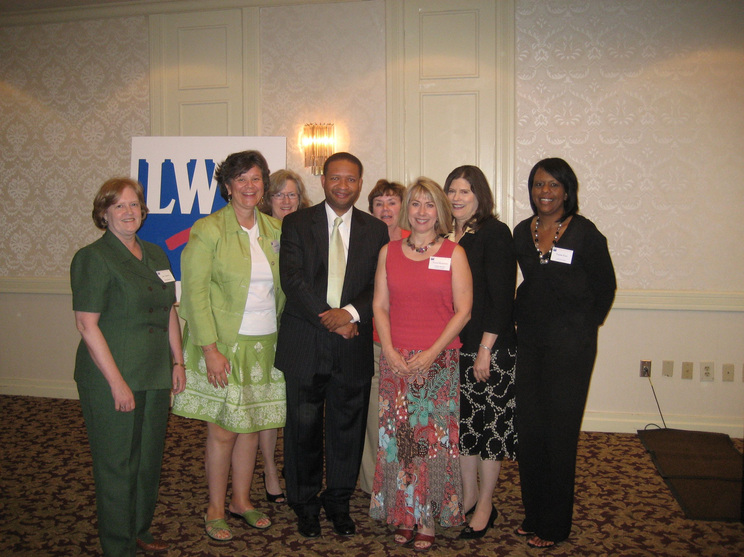

Congressman Davis was kind enough to stay to have his picture taken with the convention attendees from Birmingham.

Front Row
Jean Johnson, Kathryn Kerchof,
Congressman Artur Davis, Yvonne Brakefield

Back Row
Ginny Randolph,
Sarah McDonald,
Mary Lynn Bates,
Paulette Rowe

June 2007

A Long Goodbye

We are sad to announce that we must say goodbye to Kate Long. Kate and her husband are set to leave Birmingham in order for Kate’s husband to pursue additional medical studies. Kate has contributed greatly to Voters Service and to the Board during her short time in Birmingham. We will miss her. As a legacy she has donated the membership fees for five (and still counting) friends. Thank you Kate! Good luck and goodbye. Kate invites other members to meet her challenge and recruit five new members this year. Kate, we will report back to you on how we do on your challenge. Birmingham’s loss will be another city’s gain!
Member Profile – Yvonne Brakefield

This month The Voter has chosen to profile Yvonne Brakefield, the outgoing President of the LWVGB. Yvonne is a native of Birmingham and a graduate of UAB where she received a M.S. in Applied Mathematics. She taught mathematics at UAB before starting a career with BellSouth. Yvonne currently works as a Project Manager, but has had various jobs in her interesting 24 year career. Yvonne’s boss at UAB was the husband of Leslie O’Neil. Leslie told Yvonne in no uncertain terms that she needed to join the League and so began Yvonne’s 25 year involvement with the LWVGB. That was in December 1982 and since then Yvonne has held many positions. She has served as Secretary for the state and local league, Treasurer, Voter Editor, Technical Director for the state and local league and President of LWVGB for 2005-2007. She is currently the Secretary for the LVAL. Yvonne is a true techie. Remember she is a math major! She recounts that her most rewarding work has been when she has worked on technical projects. She really enjoyed her work on DNET. She feels DNET was an excellent way to educate the voters, and she loved the opportunity to interview the candidates as she helped to build the database. As a mother of a son soon to be 18 years old, Yvonne is particularly interested in the League reaching out to the next generation of voters. She feels the League has a wonderful opportunity for cross-generational learning. The League is full of wise members who can teach and inspire younger people about our democracy. It is a win win situation. The League needs younger members to become members in order for us to remain relevant, and our most experienced members have much to teach our youth. LWVGB thanks Yvonne for all she has done in the last 25 years and looks forward to her future contributions to our community.

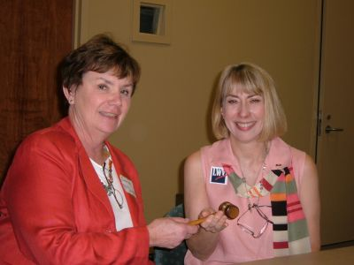

Sarah McDonald passing the gavel to Yvonne Brakefield in May 2005

June 2007

Get Out Your Walking Shoes! -- Ruffner Mountain Visit in June

Get out your walking shoes and go with us on a stroll through Birmingham’s woodland park and nature center, Ruffner Mountain, at 8:30 a.m. on Saturday June 16th. Ruffner Mountain sits along and atop Red Mountain in the East Lake area and has a terrific view of downtown Birmingham. There are ancient rocks with the waves and fossils of sea life that lived in this area when Birmingham was under the ocean. The forest is predominately hardwood filled with native birds, a few mammals and wonderful shrubs and wildflowers. For any who would like to stay, there is a native foods workshop (but please call Ruffner Mountain to reserve your place 833-8264) that Saturday morning.

Ruffner Mountain Nature Center 1214 81st Street South Birmingham, AL 35206 Tel: 833-8264
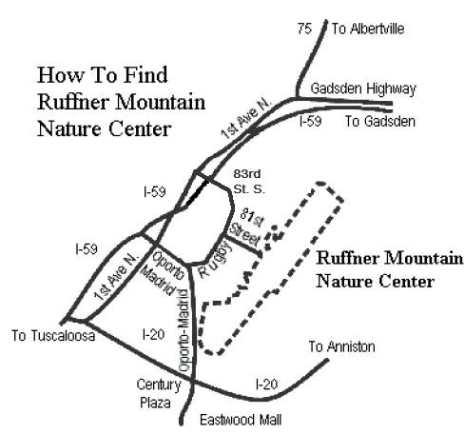

Directions:
From I-20 East: Take the Oporto-Madrid Blvd. exit (#132). Turn left onto Oporto-Madrid Blvd. Go to Rugby Ave.; turn right. Go to 81st Street, turn right.

From I-20 West: Take the Montevallo Rd. exit (#132). At the end of the exit ramp, go straight. Follow the sign to Oporto-Madrid Blvd.; turn right onto Oporto-Madrid. Go to Rugby Ave.; turn right. Go to 81st St., turn right.
From I-59 North or South: Take the 1st Ave. North exit (#132). Turn right onto 1st Ave. North. At the first intersection take a right onto 83rd St. South. Follow 83rd St. South for several blocks until it bears to the right and becomes Rugby Ave. Follow Rugby Ave. to 81st St. South, turn left.
June 2007

Moss Rock Adventure

May 19th the LWVGB went for a stroll to Moss Rock in Hoover. As you get off the busy street on a Saturday morning and walk a few feet to the trailhead, you enter the cooler realm of Moss Rock. Trees were the major vegetation as we were walking the uplands forest but as we descended into the small canyons that were wet we saw wonderful wildflowers, ferns, large boulders and waterfalls. It was a delightful respite, and Leonette Slay treated us to refreshments afterwards. All in all a perfect walk in the woods!

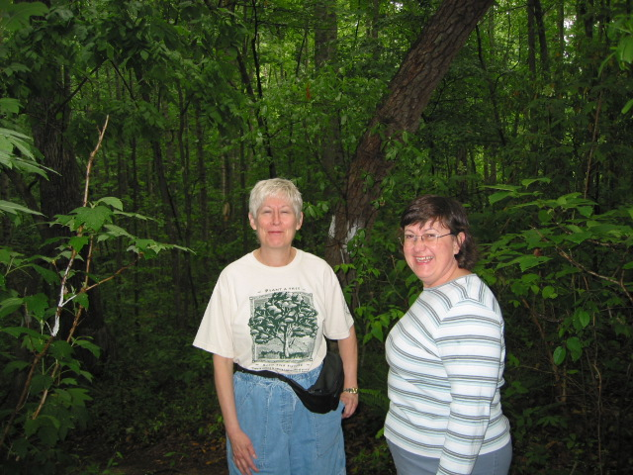

Leonette Slay and Kathy Boland at Moss Rock Preserve.

Puerto Rico Faces Recycling Challenges
Leonette Slay recently went to Puerto Rico on a business trip and discovered that the island faces a solid waste problem. Although over 100 private companies collect and process recyclable materials, the rate of recycling is only 8.8%, and only 3% is recycled into new materials or products in Puerto Rico, so the recycling companies are operating under capacity. If the solid waste authority (SWA) does not find ways to increase this percentage, the landfills will be full in 12 years. To manage waste, the SWA has unveiled a $2 billion plan which includes expanding existing landfills, recycling centers, and the development of two waste-to-energy projects (which activists there have vowed to oppose). The plan also calls for boosting the recycling rate to 35% by 2016--a goal that the government had hoped to meet in 1996. (from The San Juan Star, April 22, 2007)

Editor’s note: Many of you travel, and we are always interested in issues that you encounter that apply to the issues that concern us at the League such as transit, the environment and voting. Please forward your travel observations on to the Voter editor and we can all learn from your travels.
June 2007

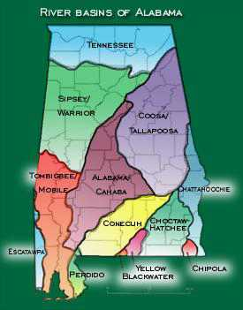
As we all know, Alabama is a water-rich state, containing over 77,000 miles of rivers and streams. All precipitation becomes part of one of 14 major river basins. As a result of our diverse waterways, Alabama ranks fifth in the nation in plant and animal diversity and first in freshwater species diversity. Protecting our waterways is therefore vital to sustaining our tremendous array of native species as well as the people, economy, and wildlife that depend on the water.
Of the 77,000 miles of water in Alabama, the Alabama Department of Environmental Management (ADEM) has only analyzed 7%. Of this 7%, a whopping 40% is considered to have poor water quality. A number of grassroots organizations have been working for decades to protect and improve our state waters. The agenda published in January (from which this information is taken) was developed from comments and direction of nine grass roots groups* and speaks to those areas with the most potential for success through policy changes. Four main areas of water health were considered to formulate actual or potential threats: water quality, water quantity, public health, and aquatic communities.
Our water quality is threatened by both direct and indirect pollution. The main sources of pollution are land development, agriculture, urban storm water runoff, and surface mining. In the area of water quantity, the major threats are excessive unregulated water withdrawals, excessive flooding within urban areas, and increasing demand for water supply for both local and out-of-state entities. Our public health is put at risk through pollution (bacteria and toxins) and fish that are unsafe to eat. Because of poor water quality, waterborne illnesses put thousands of citizens and state visitors at risk each year. Finally, aquatic communities must be protected from in-stream erosion, degraded water quality, sedimentation, and loss of stream bank vegetation. A thriving aquatic community indicates a healthy watershed. This, in turn, promotes the economy and tourism. The Alabama Water Agenda maintains that a comprehensive state water program will ensure that the four categories of water health discussed above are maintained for future Alabamians. In the next Voter, the policy strategy of this group will be summarized. We can examine this strategy in light of LWVAL positions on the environment.
*Of the 70 groups in AL dedicated to protecting water and wetlands, here are the nine that formed the peer review for the AL Water Agenda: Black Warrior Riverkeeper; Cahaba River Society; Choctawhatchee Riverkeeper; Flint River Conservation Association; Friends of Rural Alabama; Lake Watch of Lake Martin; Legal Environmental Assistance Foundation; Dan Murchison; and Save Our Soughahatchee.
Look for Leonette’s article in the next Voter on the policy changes being proposed.

REPORT OF THE ALABAMA WATER AGENDA – Leonette Slay
Earlier this year, the Alabama Rivers Alliance and Southern Environmental Law Center released "Alabama Water Agenda: Guiding the Way to Healthy Waters". This is a very readable report which can be downloaded at www.AlabamaWaterAgenda.com. I will summarize threats to Alabama water as described in the report in this Voter and policy changes that the AL Water Agenda proposes to combat the threats in the next Voter.

June 2007

LWVAL Convention May 19-20 2007

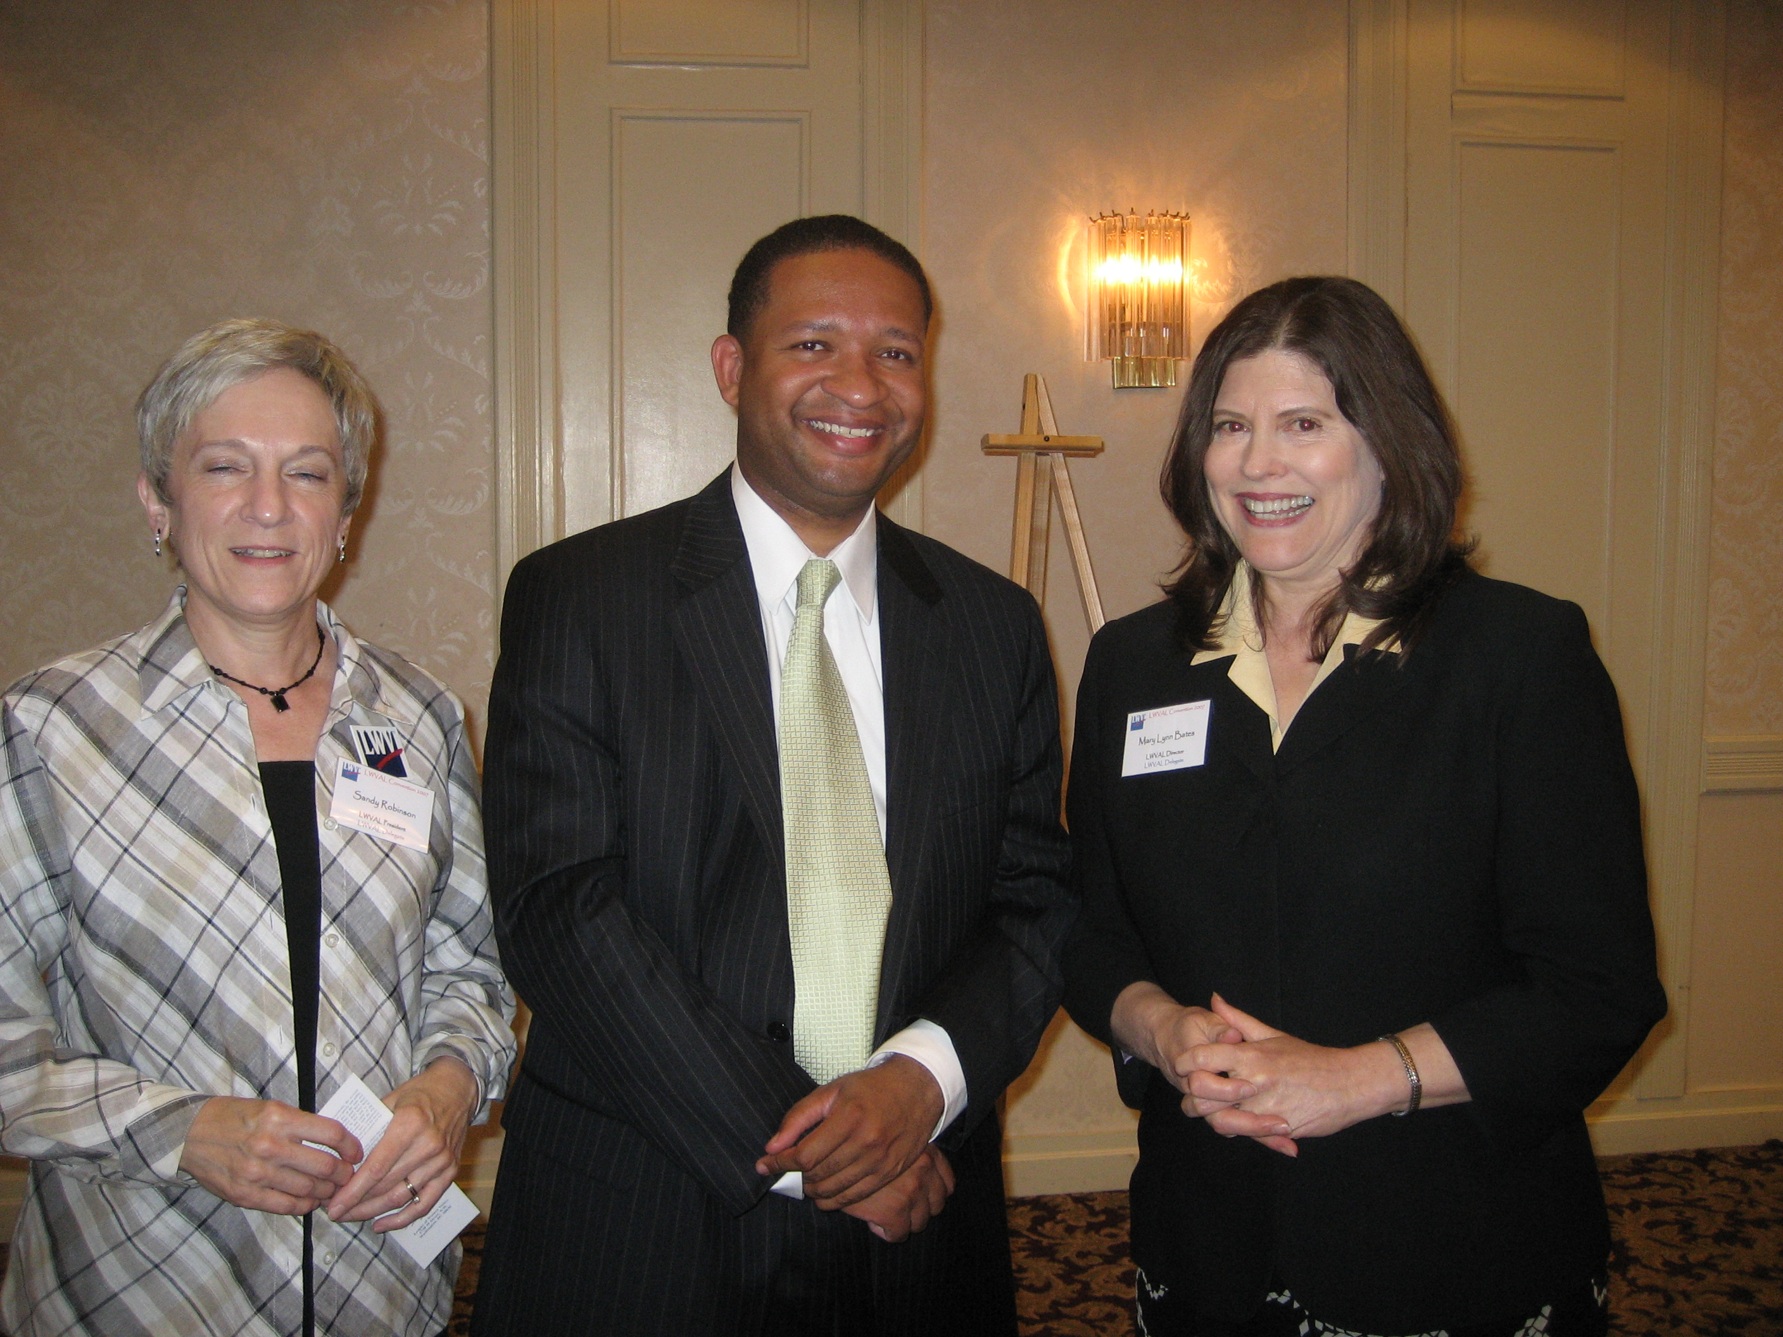
Sandy Robinson, Congressman Artur Davis and Mary Lynn Bates

Get Well Greetings

LWVGB would like to extend good well wishes to Judith Hand. Judith is recovering from surgery for a perforated appendix. We are happy to hear that Judith is out of the hospital, and we wish her a speedy recovery.

2007 – 2008 LWVGB Calendar

Month | Day | Time | Event
June | 16 | 8:30 – 11:30 | Ruffner Mountain Hike
July | 28 | 9:30 – 3:30 | Board Planning
September | 18 | 6:30 – 8:00 | Birmingham Mayoral Forum
December | 1 | 11:30 – 1:30 | Member Holiday Luncheon
April | 24 | 6:00 – 8:00 | Member Business Meeting

LWVGB
P.O. Box 530522
Mountain Brook, AL 35253

